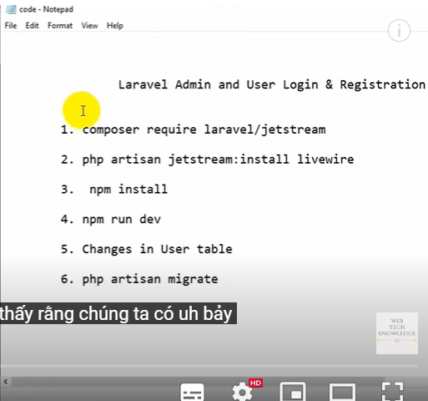
1. composer require laravel/jetstream:^3.0
2. php artisan jetstream:install livewire
3. npm install
4. npm run dev
5. Changes in User table
6. php artisan migrate

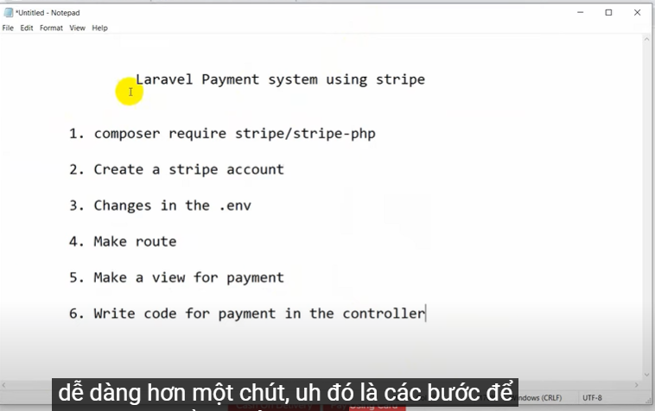
1 composer require stripe/stripe-php:^9.0

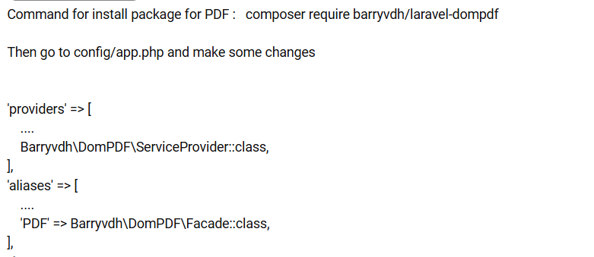
composer require barryvdh/laravel-dompdf:^2.0.1

Email Notification In Laravel( gửi mail active tài khoản)
- php artisan notifications:table
- php artisan migrate
- php artisan make:notification SendEmailNotification

Gửi maill cảm ơn: php artisan vendor:publish --tag=laravel-mail

